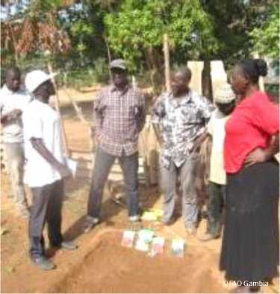

KEY FACTS

**Contribution**

USD 1 399 488

**Duration**

June 2013 - June 2019

**Resource Partner**

The Global Agriculture and Food Security Program (GAFSP)

**Partners**

The Ministry of Agriculture, the Ministry of Health and Social Welfare, the Ministry of Education, the National Nutrition Agency, Action Aid The Gambia and the National Disaster Management Agency

**Beneficiaries**

Smallholder farmers, farmer-based organizations, Government staff, the National Disaster Management Agency and the entire Gambian population, particularly at-risk households and women and children

\ Food and Agriculture Organization of the

Z United Nations

DEVELOPING CAPACITY IN AGRICULTURE, COMMERCIALIZATION, NUTRITION EDUCATION AND DISASTER MANAGEMENT IN THE GAMBIA

The agriculture sector is critical to the national economy of the Gambia, accounting for 28 percent of the gross domestic product and serving as an important source of food and income for the population. Despite being identified as a priority area in national policy and programmes, the sector has seen limited advancement due to technical and organizational capacity deficits in agricultural practices and commercialization efforts, as well as economic constraints both in terms of funding access and sectoral investment. As a result, the food security and nutrition of the Gambian population remain susceptible to shocks and disasters, particularly for the rural poor and children. In addition, women continue to face the challenge of inequitable access to information, inputs and services, despite their central role in food production. The project, funded by the Global Agriculture and Food Security Program,was therefore designed to address capacity gaps in the agriculture sector, in nutrition education and in disaster risk mitigation.

WHAT DID THE PROJECT DO?

Component 1 of the project supported smallholder farmers to adopt improved agricultural and commercialization practices. Using the Farmer Field School (FFS) approach, the capacity of farmers was developed to make better informed production decisions and increase their agricultural production. Farmer-based Organization (FBO) leadership training was also delivered to support good governance, business management, marketing, group cohesion and participatory decision making.

Component 2 of the project sustainably improved national nutrition and reduced the vulnerability of at-risk groups to disasters and shocks. This involved the performance of trainer needs assessments, revision of the national nutrition curriculum and delivery of the revised training of trainers (ToT) programme, which was designed to target primary schools, early childhood development centres and communities. Resilience was also developed by strengthening the capacity of the National Disaster Management Agency (NDMA) in disaster risk contingency planning and preparation. Finally, social protection policy and a plan for its implementation were drafted, drawing from similar programmes adopted across Africa.

IMPACT

The project aimed to increase the food security, nutrition and income levels of vulnerable households in the Gambia through the strengthening of technical and organizational capacities in agriculture, education and disaster risk management.

MAIN ACHIEVEMENTS

Project activities contributed to the delivery of a wide range of outputs, including:

* smallholder farmers being adequately trained in sustainable agriculture and organizational management, and becoming able to implement effective partnerships with relevant service providers/stakeholders to support agricultural development;
* smallholder farmers being trained in upland soil management and erosion control, and becoming able to implement more sustainable practices and better manage natural resources;
* supply chain actors and FBOs being trained in agro-processing, business management and marketing, and increasing their engagement in commercialization activities;
* the improved management of market information systems and infrastructure, with appropriate measures to ensure food quality and safety;
* key stakeholders in primary education and early childhood development centres improving their knowledge, skills and practices in nutrition and agriculture;
* rural households, and particularly mothers, improving their knowledge, skills and practices in good nutrition, food preparation and food processing;
* the strengthened capacity for local disaster risk contingency planning and preparation, and the development of household coping strategies; and
* the drafting of social protection policy that reflects the priorities and interests of communities and stakeholders.

**I**NO POVERTY

**Project Code**

FAO: UTF/GAM/029/GAM

Project Title

Technical Assistance Component of the Global Agriculture and Food Security Programme in the Gambia

Contact

FAO Representation in Gambia

[FAO-GM@fao.org](mailto:FAO-GM@fao.org)

**Partnerships and Outreach**

For more information, please contact: [Reporting@fao.org](mailto:Reporting@fao.org)

**Food and Agriculture Organization of the United Nations**

Viale delle Terme di Caracalla 00153 Rome, Italy

SUSTAINABLE DEVELOPMENT GOALS

